**Open Source Graphics & Animation Tools**

**MID-SEM EVALUATION**

**MARCH 2020**

**Submitted to**

**Dr. Durgansh Sharma**

**Professor, Cybernetics SCS, UPES**

**Submitted By**

Name: Varun Tandon

Roll No: 65

SAP ID: 500068131

B. Tech CSE (OSSOS) Department of Cybernetics

COMPUTER SCIENCE & ENGINEERING



**School of Computer Science**

**University of Petroleum and Energy Studies,**

**Dehradun – 248007: Uttarakhand**

Table of Contents

Phase- 2: 3

Project on Blender 3

Topic: Quantum Warmhole Stimulation 3

Procedure: 3

# Phase- 2:

# Project on Blender

# Topic: Quantum Wormhole Stimulation

## Procedure:

Step1: First open new project now removes the object b using right click delete.

Step2: Add circle from the add column and then press S to scale it bigger.

Step3: Now we must put the camera into center and looking downward to do that click on camera and press alt r and alt g.

Step4: To attach camera to the curve we use object constraints -->follow path -->Bezier circle.

Step5: Add an empty sphere and then constraint it to the same path as camera.

Step6: Now set offset value –2900 so the camera and sphere will be at some distance.

Step7: To make camera view towards the sphere edit camera constraints and path to Z axis.

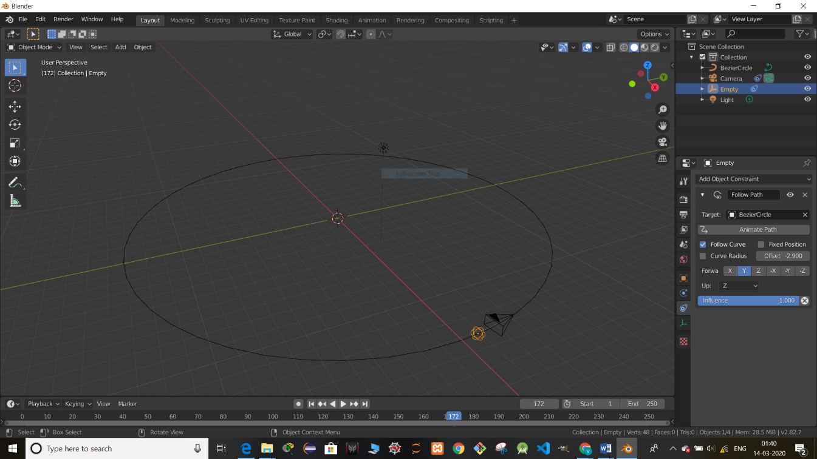

Step8: Now deform the circle to make it little more attractive animation to edit the circle select circle and press tab then to edit it and then press g to deform it as you want

Step9: Now to make the circle a tunnel goes to object data-->Geometry-->depth to 0.08 to make it a tunnel.

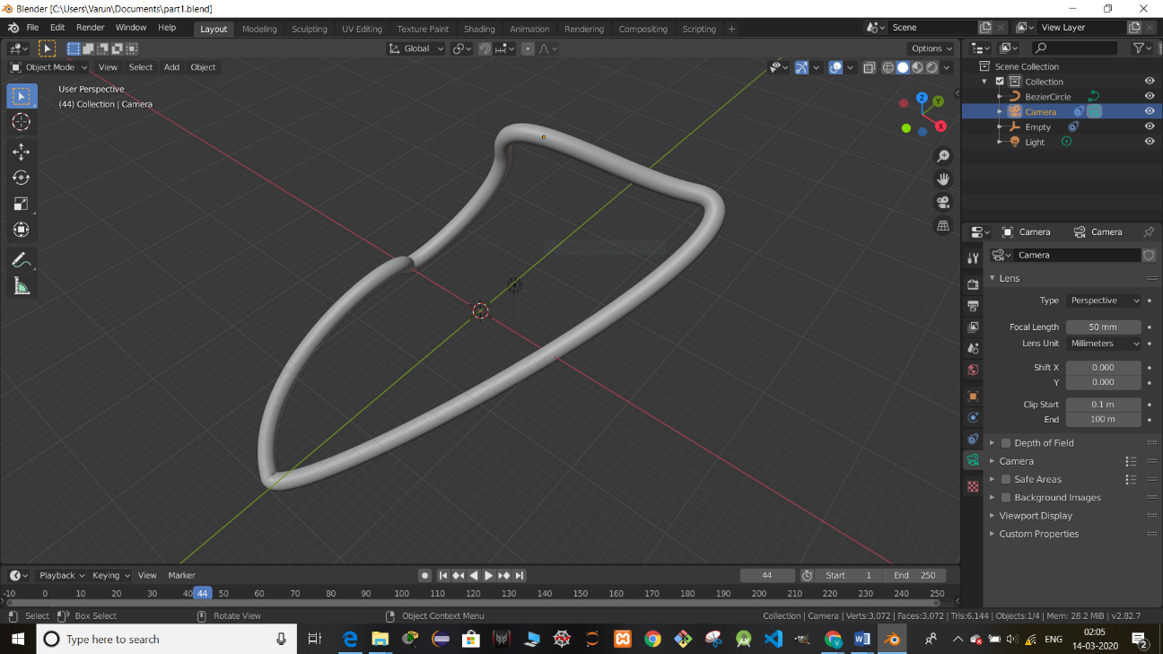

Step10: To see inside the tunnel press num0 key.

Step11: Now to give special effect to the tunnel split the screen into two parts and open shader editor in one of the parts.

Step12: In shader editor add material output, color ramp, grid.png(customized wormhole effect), Mapping , Texture coordinate

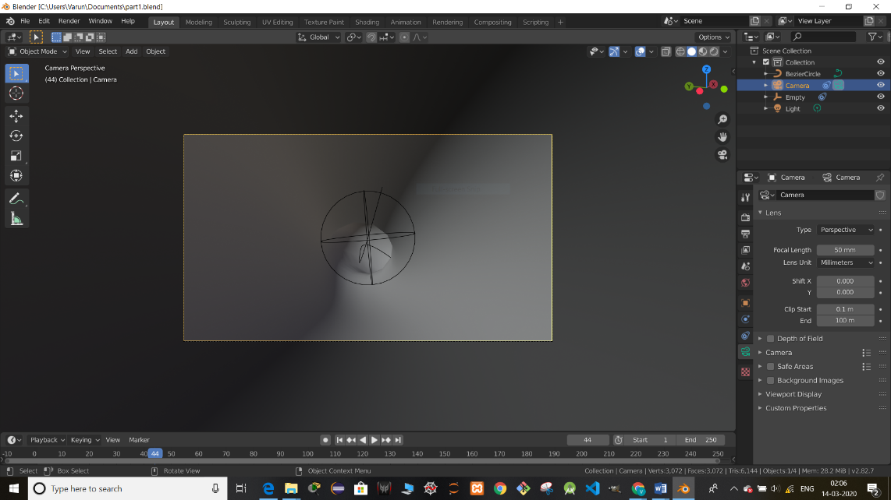

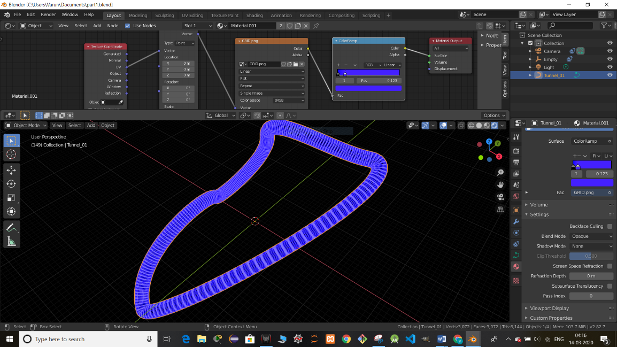

Step13: Link Material output surface with color of color ramp and the color of grid to blue (to give it a cool color effect).

Step14: Link grid.png color to Fac of color ramp.

Step15: Link Mapping vector with grid.png vector and change the X(-59.000) scale to make the animation look perfect.

Step16: Link texture coordinate link UV to vector of mapping.

Step17: For lightning use color ramp-->color panel-->select HSV increase value of value to 3.

Step18: Now render this animation with lossless option.

**Final View:**

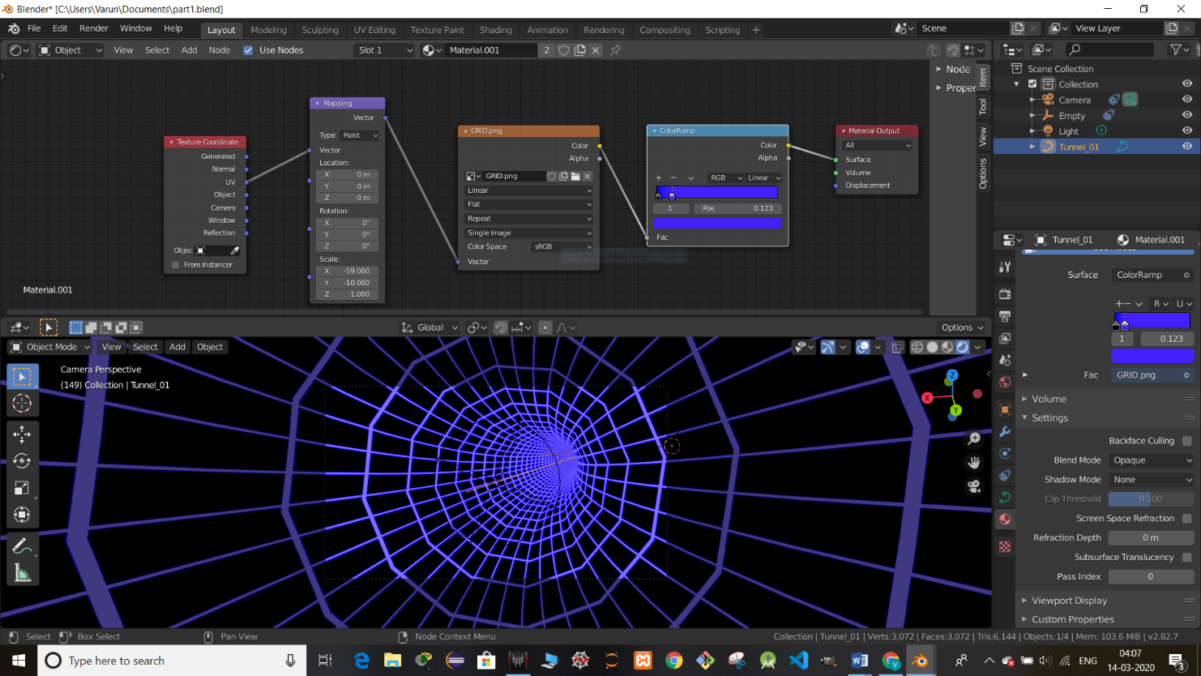

**Output:**

Output video in zip file